Запросы MySql
1) Выборка всех доступных цветов с ценой меньше 300 рублей
SELECT product_id AS
'ID товара', name AS 'Название', price AS 'Цена', stock_quantity AS 'Количество на складе'
FROM Products
WHERE is_available = 1 AND price < 300 ORDER BY price ASC;
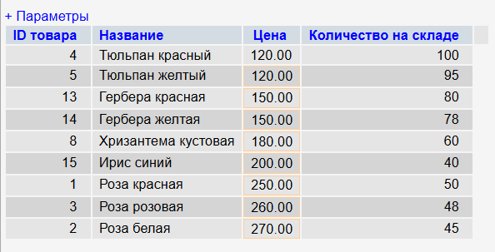
2) Выборка активных клиентов с баллами лояльности более 200
SELECT first_name AS 'Имя',
last_name AS 'Фамилия',
email AS 'Email',
loyalty_points AS 'Баллы',
registration_date AS 'Дата регистрации'
FROM Customers
WHERE is_active = 1 AND loyalty_points > 200
ORDER BY loyalty_points DESC;
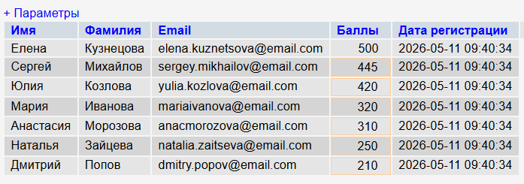
3) Выборка заказов со статусом "доставлен"
SELECT order_id AS 'Номер заказа',
order_date AS 'Дата заказа',
total_amount AS 'Сумма',
delivery_date AS 'Дата доставки'
FROM Orders
WHERE status = 'delivered'
ORDER BY order_date DESC;
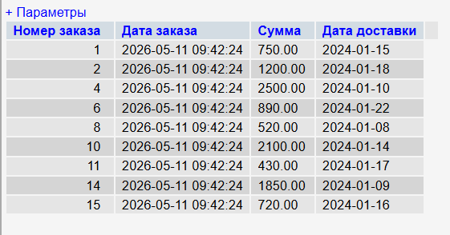
4) Выборка популярных товаров (остаток менее 30 штук)
SELECT name AS 'Название',
stock_quantity AS 'Остаток',
price AS 'Цена'
FROM Products
WHERE stock_quantity < 30 AND is_available = 1
ORDER BY stock_quantity ASC;
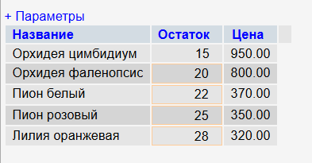
5) Выборка уникальных методов оплаты из заказов
SELECT DISTINCT payment_method AS 'Способ оплаты', COUNT(*) AS 'Количество использований'
FROM Orders
GROUP BY payment_method
ORDER BY COUNT(*) DESC;
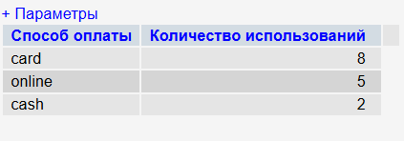
6) Запрос с JOIN: Информация о заказах с данными клиентов
SELECT o.order_id AS 'Номер заказа',
Concat (c.first_name , ' ' , c.last_name) AS 'Клиент',
c.phone AS 'Телефон', o.order_date AS 'Дата заказа',
o.total_amount AS 'Сумма', o.status AS 'Статус'
FROM Orders o
INNER JOIN Customers c ON o.customer_id = c.customer_id
WHERE o.order_date >= NOW()-Interval 1 month
ORDER BY o.order_date DESC;
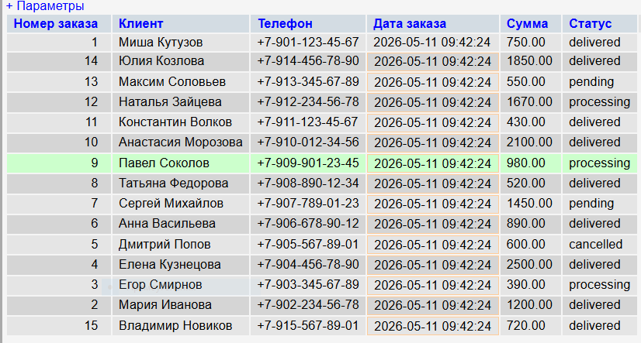
7) Запрос с JOIN: Детали заказов с названиями товаров
SELECT od.detail_id AS 'ID детали',
o.order_id AS 'Заказ №', p.name AS 'Товар',
od.quantity AS 'Количество', od.price_at_time AS 'Цена',
od.discount AS 'Скидка', od.discount AS 'Итого'
FROM order_details od
JOIN Orders o ON od.order_id = o.order_id INNER
JOIN Products p ON od.product_id = p.product_id
WHERE o.status = 'delivered' ORDER BY o.order_date DESC;
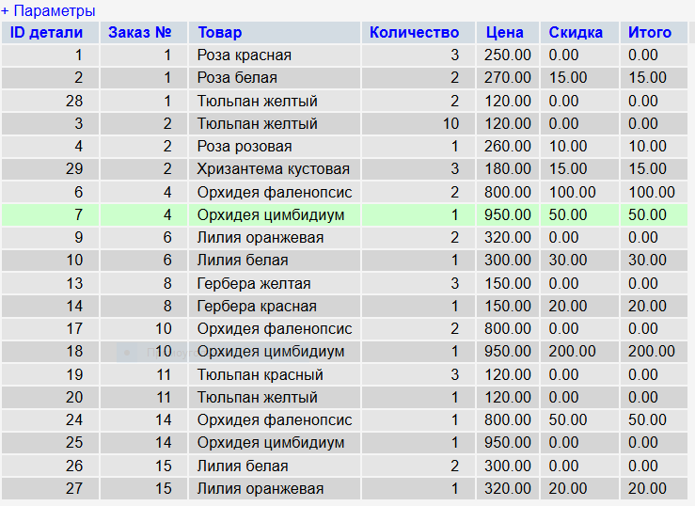
8) JOIN трех таблиц: Полная информация по заказам
SELECT c.last_name + ' ' + c.first_name AS 'Клиент',
o.order_id AS 'Заказ №',
o.order_date AS 'Дата',
p.name AS 'Товар',
od.quantity AS 'Кол-во',
od.price_at_time AS 'Сумма за позицию',
o.total_amount AS 'Общая сумма заказа'
FROM Customers c
INNER JOIN Orders o ON c.customer_id = o.customer_id
INNER JOIN order_details od ON o.order_id = od.order_id
INNER JOIN Products p ON od.product_id = p.product_id
ORDER BY o.order_date DESC, o.order_id;
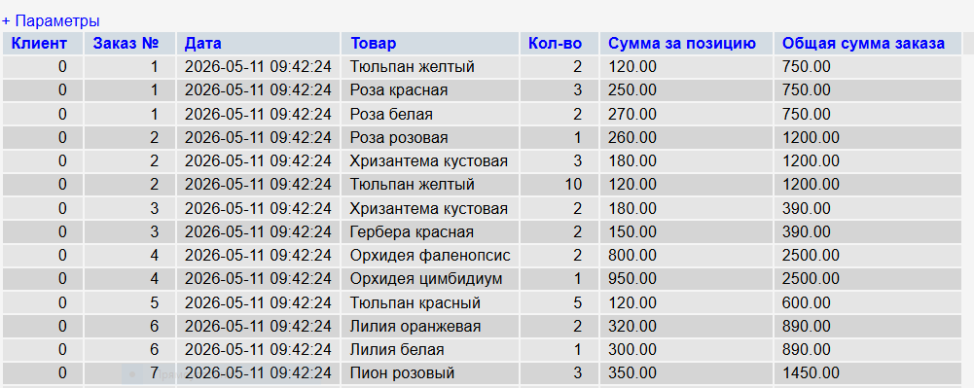
9) JOIN: заказы и количество позиций в каждом
SELECT o.order_id, COUNT(od.product_id) AS items_count, SUM(od.quantity) AS total_units FROM orders o LEFT JOIN order_details od ON o.order_id = od.order_id GROUP BY o.order_id;
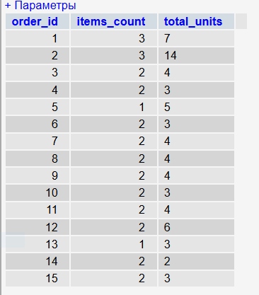
10) JOIN: товары с названиями категорий
SELECT p.name AS product_name, c.category_name, p.price FROM products p JOIN categories c ON p.category_id = c.category_id;
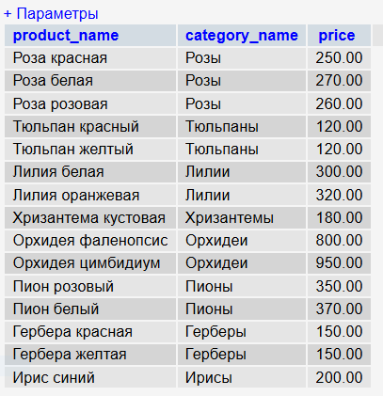
11) Агрегация с GROUP BY: Статистика по категориям товаров
SELECT cat.category_name AS 'Категория',
COUNT(p.product_id) AS 'Кол-во товаров',
MIN(p.price) AS 'Мин. цена', MAX(p.price) AS 'Макс. цена',
AVG(p.price) AS 'Средняя цена',
SUM(p.stock_quantity) AS 'Всего на складе'
FROM Categories cat LEFT JOIN Products p ON cat.category_id = p.category_id
WHERE cat.is_active = 1 GROUP BY cat.category_name
ORDER BY AVG(p.price) DESC;
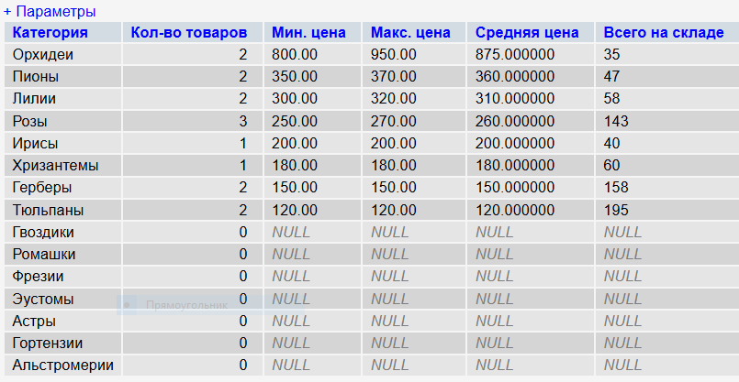
12) Агрегация с HAVING: Категории со средним чеком выше 250 руб
SELECT cat.category_name AS 'Категория',
COUNT(p.product_id) AS 'Кол-во',
AVG(p.price) AS 'Средняя цена'
FROM Categories cat
INNER JOIN Products p ON cat.category_id = p.category_id
GROUP BY cat.category_name
HAVING AVG(p.price) > 250
ORDER BY AVG(p.price) DESC;
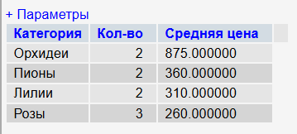
13) Группировка/агрегация: общая сумма заказов по каждому клиенту
SELECT c.customer_id, CONCAT(c.last_name, ' ', c.first_name) AS customer, SUM(o.total_amount) AS total_spent, COUNT(o.order_id) AS orders_count FROM customers c JOIN orders o ON c.customer_id = o.customer_id GROUP BY c.customer_id ORDER BY total_spent DESC;
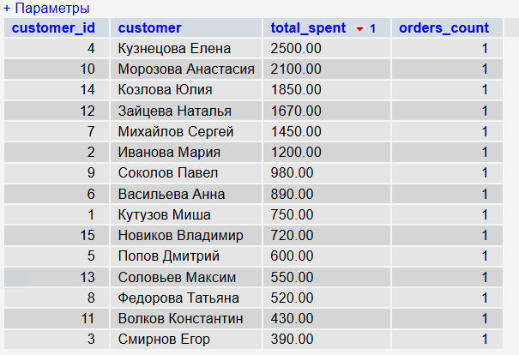
14) Группировка/агрегация: средняя цена товаров по категориям
SELECT c.category_name, AVG(p.price) AS avg_price, MIN(p.price) AS min_price, MAX(p.price) AS max_price FROM categories c JOIN products p ON c.category_id = p.category_id GROUP BY c.category_id ORDER BY avg_price DESC;
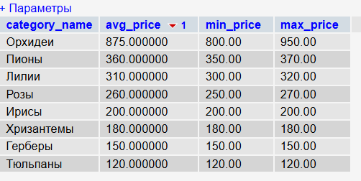
15) Группировка/агрегация: статистика по суммам заказов
SELECT MIN(total_amount) AS min_order, MAX(total_amount) AS max_order, AVG(total_amount) AS avg_order, SUM(total_amount) AS total_revenue FROM orders WHERE status != 'cancelled';
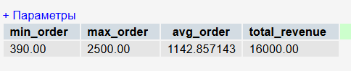
16) Вложенный запрос: Клиенты с заказами выше среднего
SELECT DISTINCT c.first_name + ' ' + c.last_name AS 'Клиент', c.email AS 'Email', (SELECT SUM(total_amount) FROM Orders o2 WHERE o2.customer_id = c.customer_id) AS 'Общая сумма' FROM Customers c WHERE EXISTS ( SELECT 1 FROM Orders o WHERE o.customer_id = c.customer_id AND o.total_amount > (SELECT AVG(total_amount) FROM Orders WHERE status = 'delivered') ) ORDER BY 'Общая сумма' DESC;
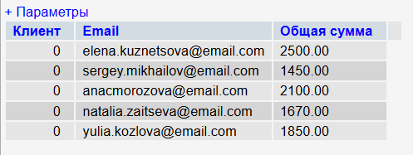
17) Объединение (UNION): список названий товаров и категорий
SELECT name AS title, 'товар' AS type FROM products UNION SELECT category_name, 'категория' FROM categories ORDER BY type, title;
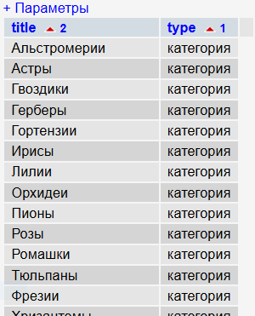

18) Объединение запросов UNION: Сводка по активности
SELECT 'Новый клиент' AS 'Тип события', first_name + ' ' + last_name AS 'Название', registration_date AS 'Дата', email AS 'Детали'
FROM Customers
WHERE registration_date >= now() - interval 1 month
UNION ALL SELECT 'Новый заказ', 'Заказ №' + CAST(order_id AS CHAR), order_date, 'Сумма: ' + CAST(total_amount AS CHAR) + ' руб.' FROM Orders WHERE order_date >= now() - interval 1 month ORDER BY 'Дата' DESC;
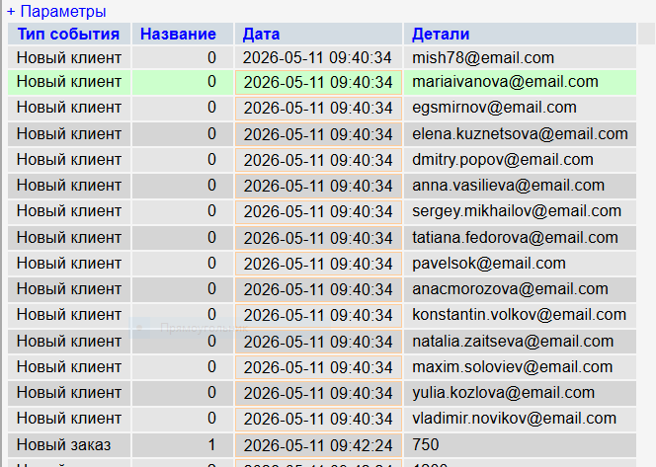
19) Функции даты/времени: заказы за последние 7 дней
SELECT order_id, customer_id, order_date, total_amount, status FROM orders WHERE order_date >= DATE_SUB(CURDATE(), INTERVAL 7 DAY) ORDER BY order_date DESC;
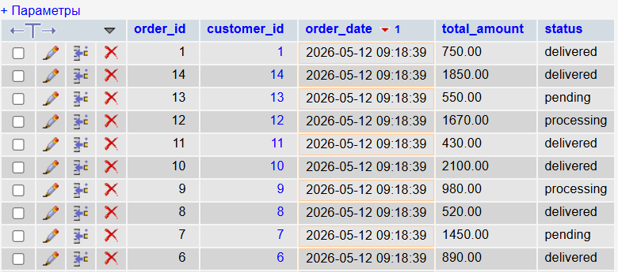
20) Числовые функции: цена товаров со скидкой 10% и округлением
SELECT name, price, ROUND(price * 0.9, 2) AS price_with_discount_10_percent, CEIL(price) AS ceil_price, FLOOR(price) AS floor_price FROM products WHERE is_available = TRUE;
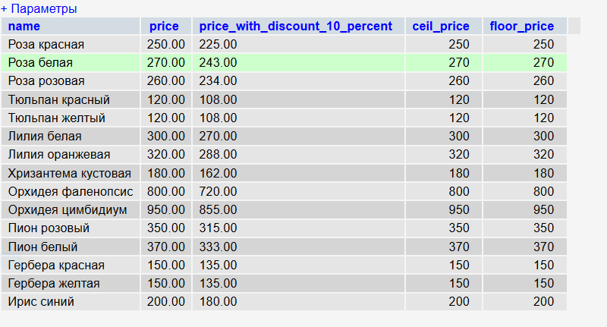
21) Строковые функции: информация о клиентах (конкатенация, email)
SELECT CONCAT(UPPER(last_name), ' ', first_name) AS full_name_upper, email, LOWER(SUBSTRING_INDEX(email, '@', 1)) AS email_login, UPPER(SUBSTRING_INDEX(email, '@', -1)) AS email_domain, CHAR_LENGTH(address) AS address_length FROM customers;
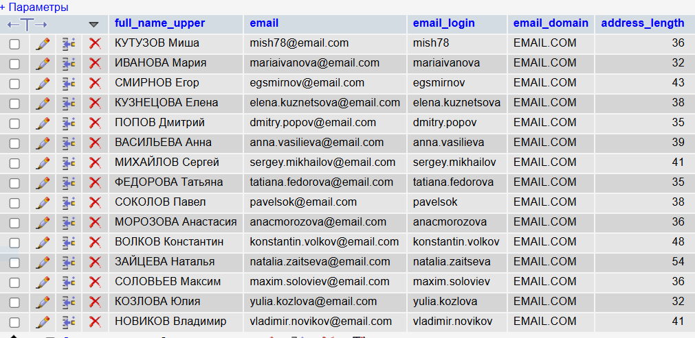
22) Переменные и управляющие конструкции: классификация заказов
SET @total_revenue = (SELECT SUM(total_amount) FROM orders WHERE status != 'cancelled'); SELECT order_id, total_amount, CASE WHEN total_amount > 1000 THEN 'Крупный заказ' WHEN total_amount BETWEEN 500 AND 1000 THEN 'Средний заказ' ELSE 'Мелкий заказ' END FROM orders WHERE status != 'cancelled' ORDER BY total_amount DESC;
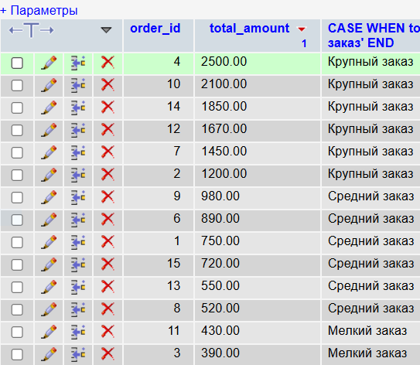
23) Хранимая процедура: оформить новый заказ
DELIMITER //
CREATE PROCEDURE sp_PlaceOrder_Simple( IN p_customer_id INT, IN p_product_ids VARCHAR(500), IN p_quantities VARCHAR(500), IN p_delivery_address TEXT, IN p_payment_method VARCHAR(10) ) BEGIN DECLARE v_order_id INT; DECLARE v_total DECIMAL(10,2) DEFAULT 0; DECLARE v_idx INT DEFAULT 1; DECLARE v_product_id INT; DECLARE v_qty INT; DECLARE v_price DECIMAL(10,2); DECLARE v_current_stock INT; DECLARE v_insufficient INT DEFAULT 0;
WHILE v_idx <= (LENGTH(p_product_ids) - LENGTH(REPLACE(p_product_ids, ',', '')) + 1) AND v_insufficient = 0 DO
SET v_product_id = CAST(SUBSTRING_INDEX(SUBSTRING_INDEX(p_product_ids, ',', v_idx), ',', -1) AS UNSIGNED);
SET v_qty = CAST(SUBSTRING_INDEX(SUBSTRING_INDEX(p_quantities, ',', v_idx), ',', -1) AS UNSIGNED);
SELECT stock_quantity INTO v_current_stock FROM products WHERE product_id = v_product_id;
IF v_current_stock < v_qty THEN
SET v_insufficient = 1;
SELECT CONCAT('Ошибка: товар с ID ', v_product_id, ' доступен в количестве ', v_current_stock) AS error_message;
END IF;
SET v_idx = v_idx + 1;
END WHILE;
IF v_insufficient = 0 THEN
SET v_idx = 1;
WHILE v_idx <= (LENGTH(p_product_ids) - LENGTH(REPLACE(p_product_ids, ',', '')) + 1) DO
SET v_product_id = CAST(SUBSTRING_INDEX(SUBSTRING_INDEX(p_product_ids, ',', v_idx), ',', -1) AS UNSIGNED);
SET v_qty = CAST(SUBSTRING_INDEX(SUBSTRING_INDEX(p_quantities, ',', v_idx), ',', -1) AS UNSIGNED);
SELECT price INTO v_price FROM products WHERE product_id = v_product_id;
SET v_total = v_total + (v_price * v_qty);
SET v_idx = v_idx + 1;
END WHILE;

INSERT INTO orders (customer_id, total_amount, delivery_address, payment_method, status)
VALUES (p_customer_id, v_total, p_delivery_address, p_payment_method, 'pending');
SET v_order_id = LAST_INSERT_ID();
SET v_idx = 1;
WHILE v_idx <= (LENGTH(p_product_ids) - LENGTH(REPLACE(p_product_ids, ',', '')) + 1) DO
SET v_product_id = CAST(SUBSTRING_INDEX(SUBSTRING_INDEX(p_product_ids, ',', v_idx), ',', -1) AS UNSIGNED);
SET v_qty = CAST(SUBSTRING_INDEX(SUBSTRING_INDEX(p_quantities, ',', v_idx), ',', -1) AS UNSIGNED);
SELECT price INTO v_price FROM products WHERE product_id = v_product_id;
INSERT INTO order_details (order_id, product_id, quantity, price_at_time, discount)
VALUES (v_order_id, v_product_id, v_qty, v_price, 0);
UPDATE products SET stock_quantity = stock_quantity - v_qty
WHERE product_id = v_product_id;
SET v_idx = v_idx + 1;
END WHILE;
UPDATE customers SET loyalty_points = loyalty_points + FLOOR(v_total / 100)
WHERE customer_id = p_customer_id;
SELECT v_order_id AS order_id, v_total AS total_amount, 'Заказ создан' AS message;
END IF;
END //
DELIMITER ;
24)Хранимая процедура отчёта по продажам
DELIMITER //
CREATE PROCEDURE sp_SalesReport_Fixed(IN p_start_date DATE, IN p_end_date DATE) BEGIN SELECT DATE(o.order_date) AS sale_date, COUNT(DISTINCT o.order_id) AS orders_count, SUM(od.quantity) AS units_sold, SUM((od.price_at_time * od.quantity) - od.discount) AS revenue, ROUND(AVG(o.total_amount), 2) AS avg_order_value FROM orders o JOIN order_details od ON o.order_id = od.order_id WHERE DATE(o.order_date) BETWEEN p_start_date AND p_end_date AND o.status != 'cancelled' GROUP BY DATE(o.order_date) ORDER BY sale_date; END //
DELIMITER ;
25)Триггер BEFORE INSERT на order_details – проверка остатка товара
CREATE TABLE IF NOT EXISTS stock_log ( log_id INT PRIMARY KEY AUTO_INCREMENT, product_id INT, attempted_quantity INT, current_stock INT, error_message VARCHAR(255), log_time TIMESTAMP DEFAULT CURRENT_TIMESTAMP );
DELIMITER // CREATE TRIGGER before_order_details_insert BEFORE INSERT ON order_details FOR EACH ROW BEGIN DECLARE v_stock INT; SELECT stock_quantity INTO v_stock FROM products WHERE product_id = NEW.product_id; IF v_stock < NEW.quantity THEN INSERT INTO stock_log (product_id, attempted_quantity, current_stock, error_message) VALUES (NEW.product_id, NEW.quantity, v_stock, 'Недостаточно товара на складе'); SIGNAL SQLSTATE '45000' SET MESSAGE_TEXT = 'Недостаточно товара на складе'; END IF; END // DELIMITER ;
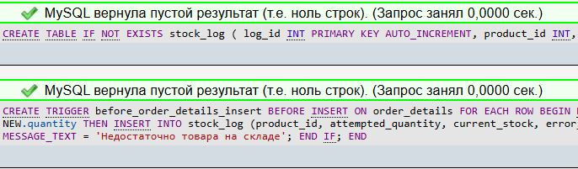
26)Триггер автоматическое заполнение даты обновления товара
CREATE TRIGGER prevent_negative_quantity BEFORE INSERT ON order_details FOR EACH ROW BEGIN IF NEW.quantity <= 0 THEN SIGNAL SQLSTATE '45000' SET MESSAGE_TEXT = 'Количество товара должно быть больше 0'; END IF; END //

DELIMITER ;

27) Триггер BEFORE DELETE на customers – запрет удаления, если есть заказы
DELIMITER // CREATE TRIGGER before_customer_delete BEFORE DELETE ON customers FOR EACH ROW BEGIN DECLARE order_exists INT; SELECT COUNT(*) INTO order_exists FROM orders WHERE customer_id = OLD.customer_id; IF order_exists > 0 THEN SIGNAL SQLSTATE '45000' SET MESSAGE_TEXT = 'Нельзя удалить клиента с существующими заказами'; END IF; END // DELIMITER ;
28) Представление: активные товары с категориями
CREATE VIEW active_products_with_categories AS SELECT p.product_id, p.name, p.price, p.stock_quantity, c.category_name, c.category_id FROM products p JOIN categories c ON p.category_id = c.category_id WHERE p.is_available = TRUE AND p.stock_quantity > 0;
29) Представление: итоги по клиентам (сумма, количество заказов)
CREATE VIEW customer_summary AS SELECT c.customer_id, CONCAT(c.last_name, ' ', c.first_name) AS customer_name, c.email, c.loyalty_points, COUNT(o.order_id) AS total_orders, SUM(o.total_amount) AS total_spent, AVG(o.total_amount) AS avg_order_amount, MAX(o.order_date) AS last_order_date FROM customers c LEFT JOIN orders o ON c.customer_id = o.customer_id AND o.status != 'cancelled' GROUP BY c.customer_id;
30)Представление: ежедневные продажи
CREATE VIEW daily_sales AS SELECT DATE(o.order_date) AS sale_date, COUNT(DISTINCT o.order_id) AS num_orders, SUM(od.quantity) AS items_sold, SUM(od.price_at_time) AS daily_revenue, COUNT(DISTINCT o.customer_id) AS unique_customers FROM orders o JOIN order_details od ON o.order_id = od.order_id WHERE o.status != 'cancelled' GROUP BY DATE(o.order_date) ORDER BY sale_date DESC;

